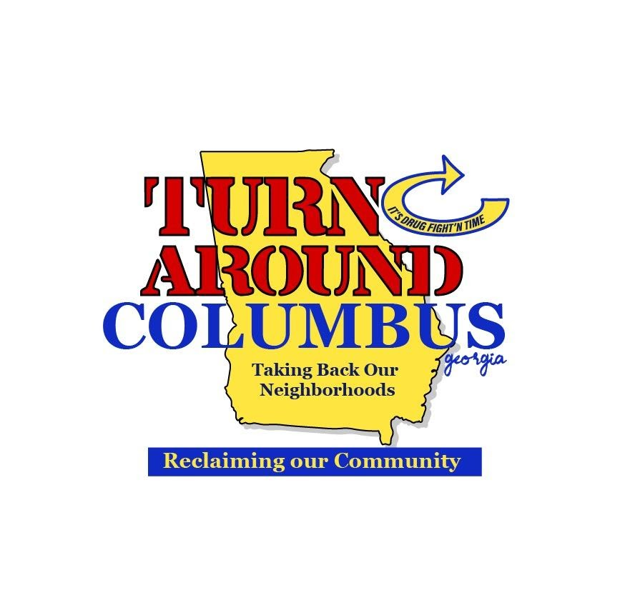
612 Dirk Way Columbus, GA 31907
turnaroundcolumbus@gmail.com 706-442-8044

“Improvise, Adapt and Overcome”
-Marine Corps Motto

FOR IMMEDIATE RELEASE

Outdoor Learning Study Committee Highlights Dr. Martin Luther King, Jr. Outdoor Learning Trail

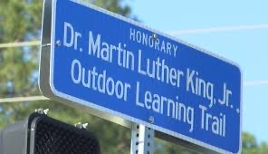

A unique Columbus asset, The Dr. Martin Luther King Outdoor Learning Trail was highlighted in the Georgia State Senate Outdoor Learning Study Committee..

The five member Committee chaired by Sen Senator Sheikh Rahman from District 5 included Columbus’ Senator Ed Harbison. The legislators heard testimony from 18 varied outdoor learning experts, organizations, advocates and teachers.

The 2021 final report recorded remarks from Sen. Harbison, “Senator Harbison discussed the MLK Outdoor Learning Trail, located in Columbus, Georgia, and described its location and learning stations. He believes the Trail is a tremendous learning opportunity for children.”

The outdoor classroom opportunities of the eleven site Dr. Martin Kuther King, Jr. Outdoor Learning Trail have expanded to include the George Washington Carver Victory Gardens & Farm. The Gardens & Farm are a children and youth focused partnership that offers MCSD youth an outdoor multifaceted learning environment and entrepreneurship training.

The Committee’s recommendation’s preamble stated “the Committee determined that engagement with the outdoors has an extremely positive effect when implemented both in a school and an extra- curricular setting. After substantial discussion and review, the Committee finds a need to emphasize outdoor learning opportunities and generally increase access to the outdoors for both children and young adults.”

Committee’s seven recommendations included , “The Committee encourages the inclusion of an ongoing program similar to “The MLK Jr. Outdoor Learning Trail,” in Columbus, Georgia, in student’s curriculum statewide. Students should have the opportunity to engage in nature, civics, and gardening as a result.”

Other recommendations covered:
- Advocating for a state level “Office of the Outdoors to optimize outdoor learning, engagement, and recreation efforts across state government departments and with non-state partners.”
- Encouraging “funding or other support to ensure that each Georgia child participates in regular, meaningful outdoor learning experiences….” and
- Promoting “the creation of a grant program available to both schools and non-profit providers of outdoor learning and environmental education…”

For more information contact Ronzell Buckner, Turn Around Columbus at (706) 442-8044 or email turnaroundcolumbus@gmail.com

