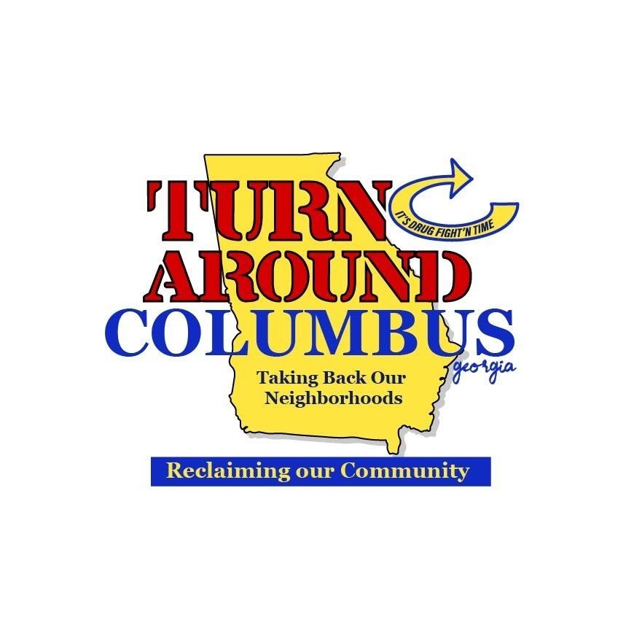
“Improvise, Adapt & Overcome”
Marine Corps Motto

Home of
George Washington Carver Victory Garden & Farm &
Dr. Martin Luther King, Jr. Outdoor Learning Trail

“Give vegetables and he eats for a day but teach him to plant a garden and he eats for a lifetime.”

Food Freedom Spreading “Climate Victory Gardens”
“Although Victory Gardens first appeared during World War I, former slave and agrarian scientist, George Washington Carver, brought them back into the national consciousness when he promoted the idea in a 1942 agricultural tract for the Tuskegee Institute of Alabama. Victory gardens caught on around the nation, and soon civilians everywhere were growing food for themselves and their communities. The gardens popped up in backyards, vacant lots, school grounds, and even in city-owned parks where residents could all participate in growing food.

TAC’s The George Washington Carver Victory Garden & Farm is working to carry on his legacy training how you can create your own Climate Victory Garden.

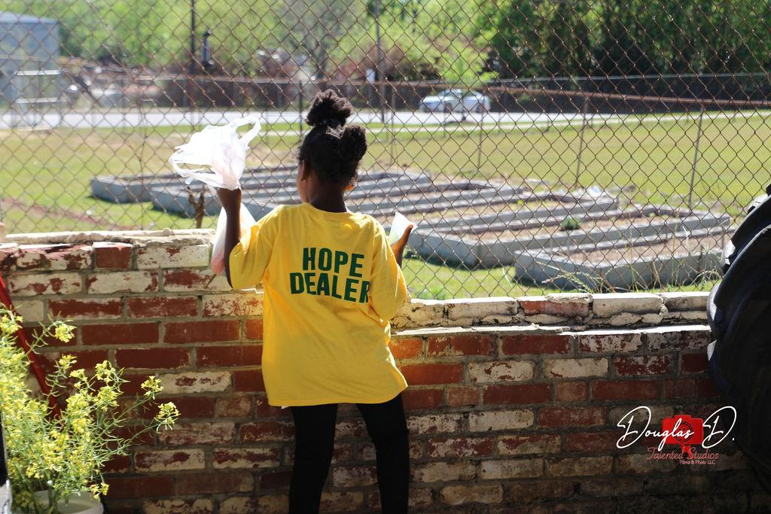
“Save the babies, Save the children”

Bringing Back Victory Gardens to battle Food deserts, health and climate
“Planting a garden has the power to change the world.
- From right in your backyard (or front, or patio, or simple pot), you have the ability to strengthen your own local food system.
- And, when you make your garden regenerative, you can also help reverse global warming by restoring soil health.”

“We are once again in the position where we, as everyday citizens, have the opportunity to use our gardens as a force for change. Instead of gardening in support of war efforts, we are gardening to fight global warming.;Soil equals life.”

