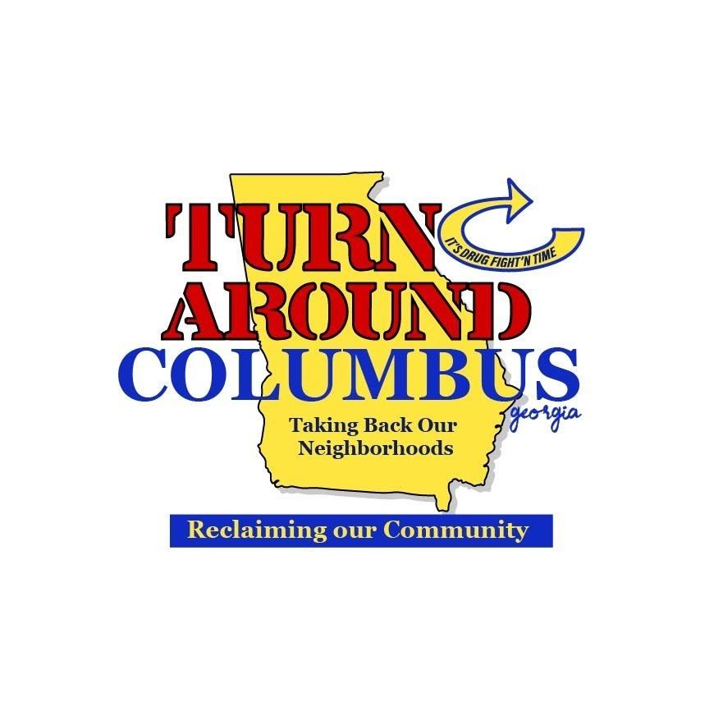
612 Dirk Way Columbus, GA 31907
turnaroundcolumbus@gmail.com 706-442-8044

“Improvise, Adapt and Overcome”
-Marine Corps Motto

Turn Around Columbus (TAC)
Hope Dealers Job Description

TAC Hope Dealers: Meaningful youth employment and hands-on educational entrepreneurial training opportunities.
- Hope Dealers: program is for high school students to get on-the-job agricultural and entrepreneurial training. They’ll learn about managing and running the Farm business.
- Fort Valley State University: has committed to allow our students to be eligible for a full ride scholarship if they choose a field in agriculture, participate in this program, and maintain a 3.0 grade point average. Tutoring is available if requested.
- Initiative includes:
  - On-the-job entrepreneurial and leadership training and farming apprenticeship
  - Weekly schedule of production tasks to operate and manage a small farm
  - Weekly food harvesting, sales and distribution
  - Summer Hope Dealers could qualify for the 10 Youth Farm Leader (Hope Dealer) part-time jobs positions be paid year-round.
- Hope Dealer Applications Required (see Director for copies)
  - TAC Application and Authorizations
  - City of Columbus, GA Summer Jobs program application

